TMT/Dadri/S0686/2026 24-02-2026

To,

Vinayak Nair
Mobile No :
+918208346854
City : 'Dadri'
State : '''Uttar Pradesh'''

Dear sir,

Sub :- Supply of 100 MT C-TYPE HYDRAULIC PRESS.

This is reference to your enquiry for the hydraulic press; we offer our least possible price as under.

C TYPE PRESS :

1) Tonnage : 100MT.

S No | Description of the unit | Offer
1. | C Type Hydraulic Press with capacity 100 Metric tons. with Power pack of 15 HP motor and with complete electrical.  Hydraulic power pack along with motor 5 hp motor  Tank 200 lts  Yuken vane pump 180 lpm  Piston pump 30.0 lpm  Pressure guage 1 No  Level indicator 1 No  Section filter 1 No  Return line filter 1 No  Section strainer 1 no  Manifold block 1 no  Pressure control valve 1 no  Solenoid operated direction control valve 1 nos  Pipes and fittings.  Bell housing 1 no  Pressure guage 0-250 kg 1 no  Flexible houses 2 nos  Nylon gear coupling 1 no | Rs 6,50,000/-  (Rupees Six Lakhs Fifty Thousand only)

SPECIFICATIONS FOR THE HYDRAULIC PRESS MACHINE WITH 100MT

1. Tonnage : 100 M.T.

2. Clearance between Housings : 450mm

3. Daylight : 250 mm

4. Ram stroke. : 150 M.M.

5. Open height. : 450 M.M.

6. Closed height. : 300 M.M.

7. Depth of Throat. : 450 M.M.

- Ram speeds.

a) Approach. : 12 M.M. per Sec.

b) Pressing. : 2 M.M. per Sec.

c) Return. : 20 M.M. per Sec.

9. Motor capacity. : 7.5 H.P. (Crompton)

10. Bed size. : 750 x 550 M.M.

12. Cost of Machine. : Rs.6,50,000/- + Taxes.

13. Mode of payment. : As per the quotation.

14. Delivery. : As per the quotation.

GENERAL TERMS & CONDITIONS:

1 Price quoted per unit ex-work. Hyderabad.
2 Following charges are additional to your account.
- Freight Charge : As actual to be borne by you.
- Excise : 10.30%
- Sales Tax : 4% Vat.
- Packing charge : As actual to be borne by you.
- Insurance : As actual to be borne by you.
3Payment : 50% advance alongwith order another 25%
advance after 3 weeks from first advance and
balance before delivery but after inspection at our
works.
- Delivery : 5-6 weeks from date of techno-commercially clear
purchase order.
- Validity : One month from the date of submission.
- Inspection : Inspection at our works prior to dispatch.
- Warranty : The machine is warranted for a period of 12
months from the date of dispatch against any
manufacturing defects/faulty material or bad
workmanship of any part or component but not
against any kind of abnormal or improper use of
machine. Defective part or component will be
replaced or repaired free of cost. Electrical
components are outside the scope of this
warranty.
- Commissioning : Erection & commissioning done by you, but if
required technical support & guidance provide by
us at additional cost.

NOTE:

- Oil is not in scope of our supply.
- Raw material for trial is arranged by you at your cost.

We are sure you will find our offer in line with your requirements. Should you require any further clarification please call us on mobile number 9246221106.

Thanking you and assuring you of our best services.

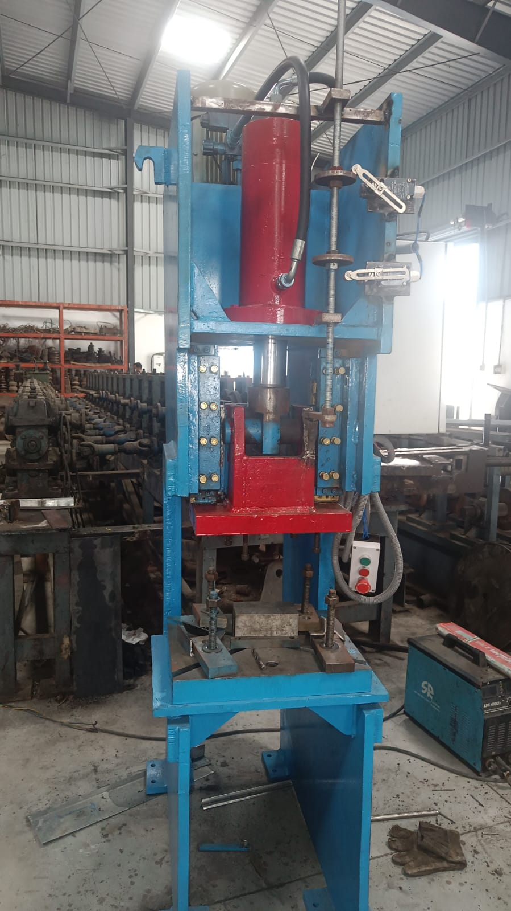

For TECHNO MACHINE TOOLS

T.SIVARAMAKRISHNA

